**MongoDB Assignment 1**

Question 1: Insert Documents

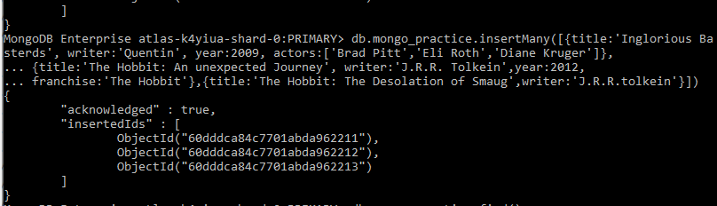

Final Result after complete insert

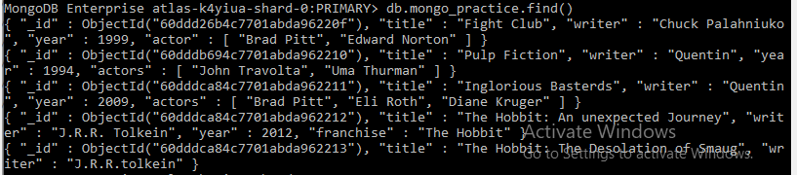

Question 2 Query/Find

1)

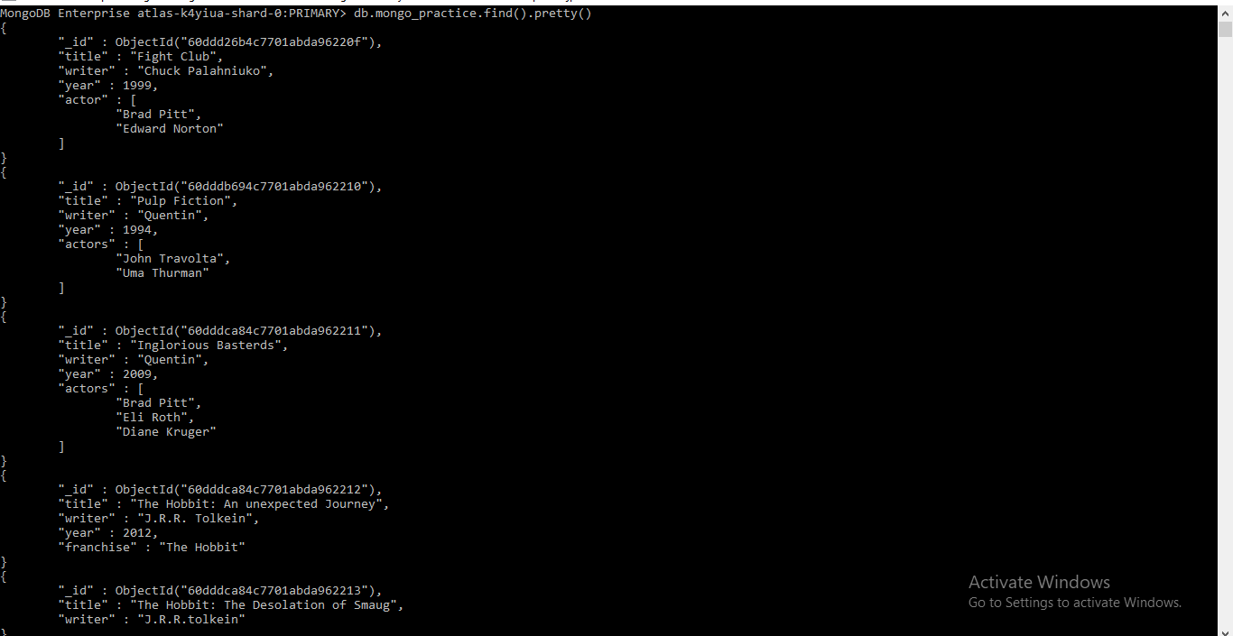

2)

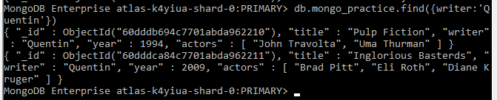

3)

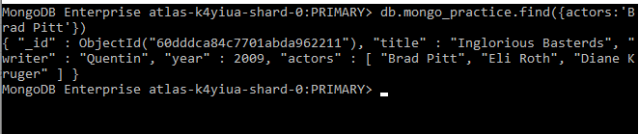

4)

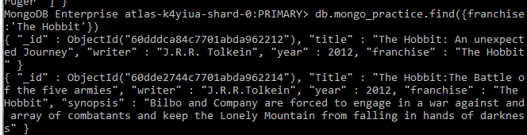

5)

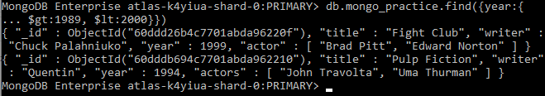

6)

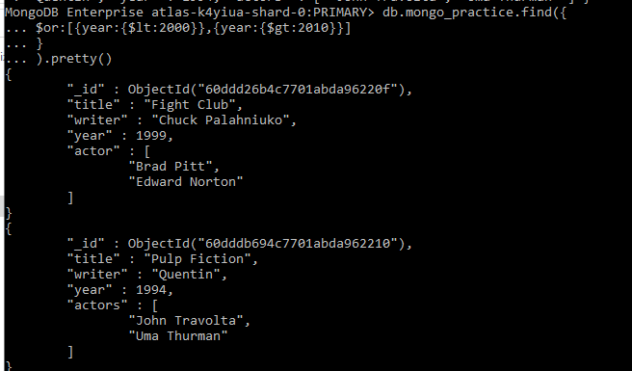

**3) Update Documents**

1.



2.

new2.PNG

3.



Results after Updates

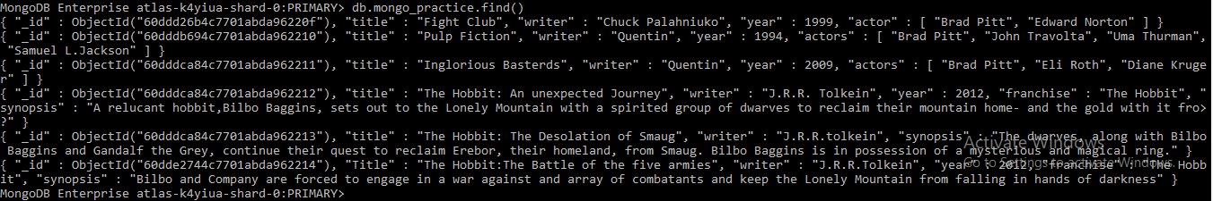

**4) Text Search**

1. bilbonewcm.PNG

2. 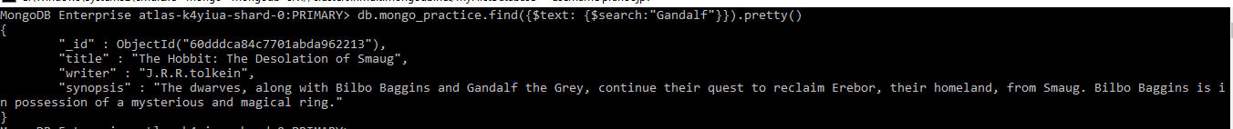

3.

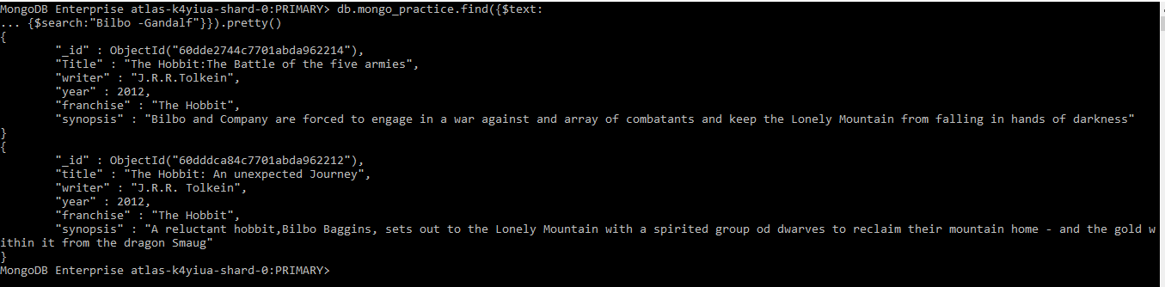

4.

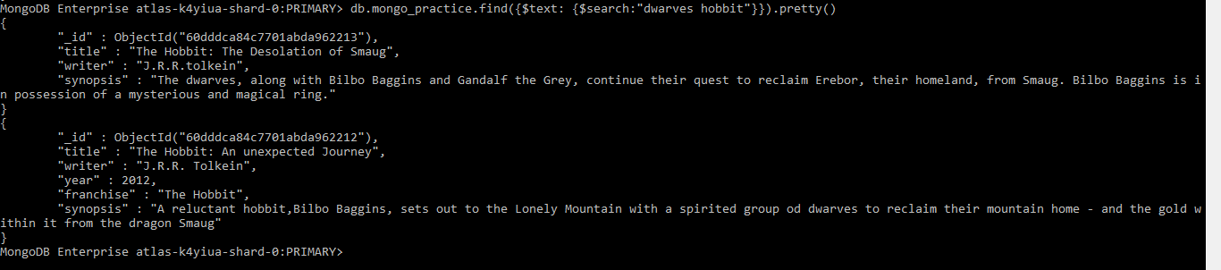

5.

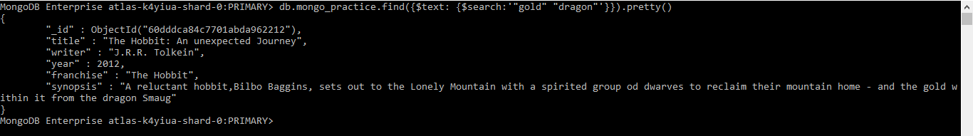

**5) Delete Documents**

1. db.mongo_practice.deleteOne({title:’Pee Wee Hermans Big Adventure’})

2. db.mongo_practice.deleteOne({title:’Avatar })

**6) Relationships**

1.

findusers (2).PNG

2.

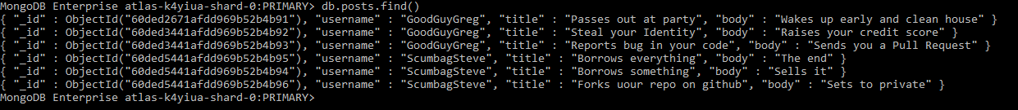

3.

Capture1.PNG

4.



5.

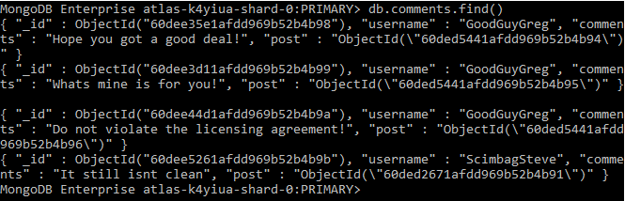

6.

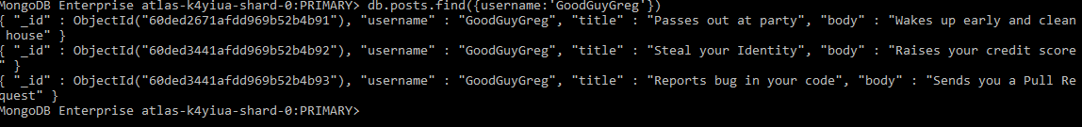

7.



8.

report bug.PNG